T

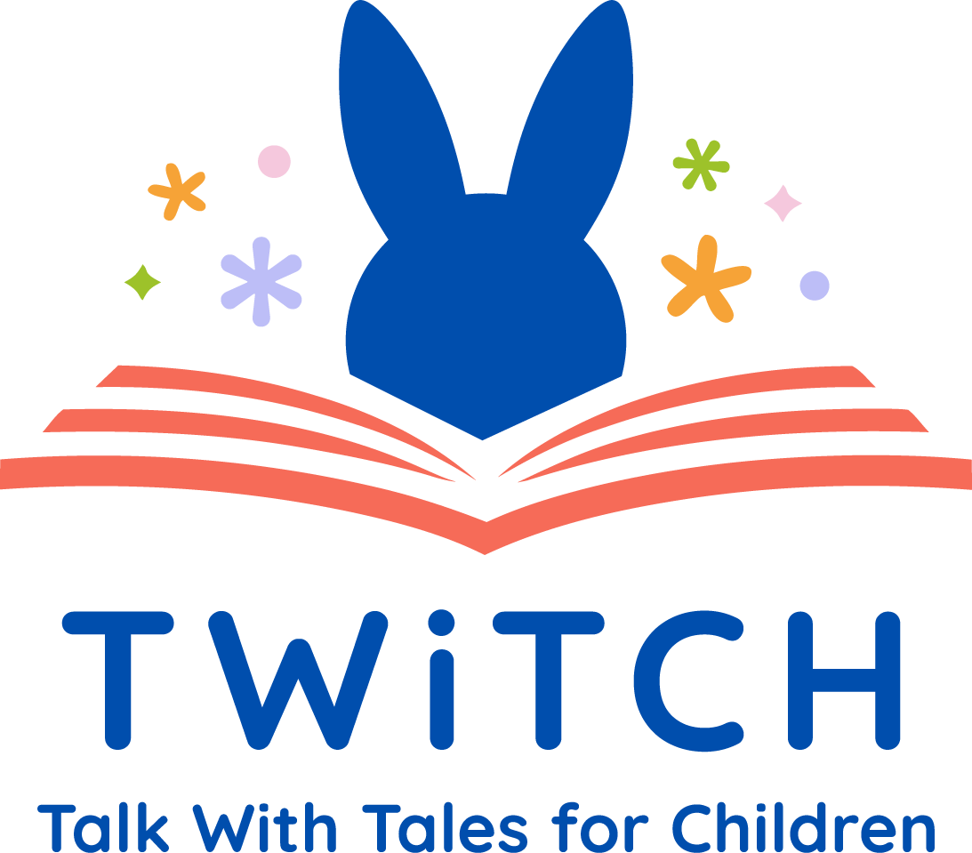

The National Literacy Trust has a brand-new partnership with Sheffield Hallam University to deliver Talk With Tales for Children (TWiTCH) programme from September 2026. TWiTCH seeks to reduce language inequalities, support better outcomes for young children through building staff confidence and expertise in using dialogic techniques as part of shared reading experiences.
What is the impact of TWiTCH?
The EEF Pilot trial carried out by Sheffield Hallam University showed practitioners had improved questioning and discussion skills, made greater use of reasoning-focused questions and reflection time. Whilst children showed a stronger enjoyment and engagement in stories, greater confidence to speak, share opinions, and give reasons. Children were also found to have use of longer sentences and more expressive language which supported improved reasoning and narrative understanding.
What does the TWiTCH programme involve?
TWiTCH trains early years practitioners to use dialogic reading strategies alongside the daily shared reading of traditional tales to support children’s language and communication skills. Using the traditional tales provided in the TWiTCH resource pack, practitioners will deliver a series of story cycles, each lasting three weeks, as part of regular story time. Daily activities take 10-15 minutes.

Week 1: Developing children’s understanding of the story and providing opportunities for discussion about characters and events.
Week 2: Deepening discussion through choice-based activities focused on the moral dilemmas within the stories.
Week 3: Supporting children to apply their story knowledge in play (e.g. through continuous provision), with additional support for children who need it.

What support is provided for EY settings?

Each setting will be supported by a named TWiTCH coach for the duration of the year long
programme.

The coach will deliver:
- Initial TWiTCH training (2 x 3hrs)
- Up to three coaching visits (online, face to face, emails etc).

Setting leaders will be asked to:
- Ensure all the staff who will be delivering TWiTCH attend the training (minimum 2 practitioners)
- Appoint a TWiTCH Champion,

The TWiTCH Champion will:
- Attend online Champion training (2 hours)
- Attend two online network events (2 × 30 minutes)
- Support their colleagues with implementation and evaluation activities

Are there any costs involved?

No. The TWiTCH programme is a fully funded programme which is free for all participating settings. Settings will however, need to ensure they are able to commit attendance to the initial training. This can be arranged to accommodate each setting.

What is the timeline for Year 1 programme?

June -September 2026 | Settings invited to express interest, attend information webinars and complete a partnership agreement
September – Dec 2026 | Pre-programme evaluations completed  Initial training delivered for practitioners and Twitch Champions
October 2026 – Jan 2027 | Delivery of story cycles begin
Jan – June 2027 | Coaches offer support for settings and network sessions for Twitch champions
July 2027 | Celebration, evaluation of impact and post programme surveys.

Eligibility criteria:

Are you an early years provider that:
- Offers funded places for 3 and 4-year-olds?
- Have sufficient space and staffing to run story time with small groups of children?
- Have a minimum of two staff working with preschool cohorts?
- Have not previously taken part in TWiTCH training?
- Able to commit to attending training and delivering story cycles across the year?
- Is willing to provide feedback or evaluation information?

Register your interest here

Join one of our free information briefings to find out more:

7th July 2-3pm
14th July 7-8pm
8th Sept 2-3pm
10th Sept 7-8pm

Email twitch@literacytrust.org.uk

